Hi everyone,

Here is where we at.
- upload a local XML to database
- Get store address in server
- Open uploaded XML in server and show the content.

Choose a local XML file
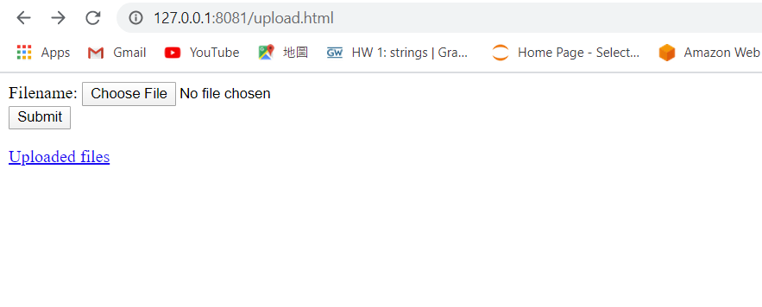

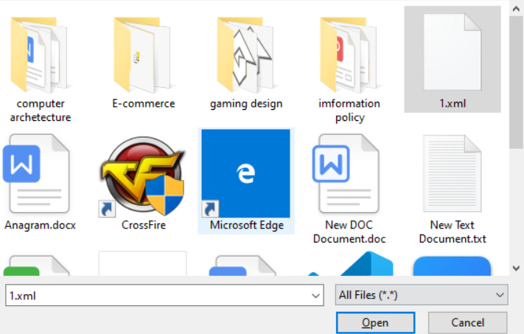

Upload file to database by clicking submit


After uploaded a file, we can see the where we store
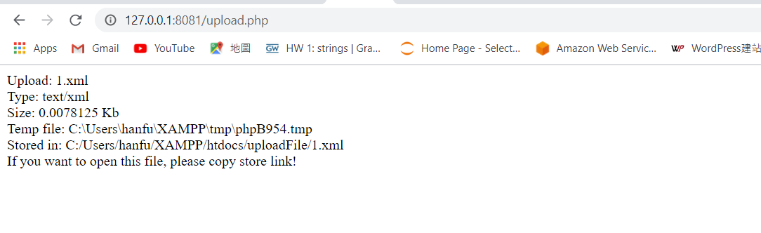
Now, it can show the store uploaded file and show file’s address
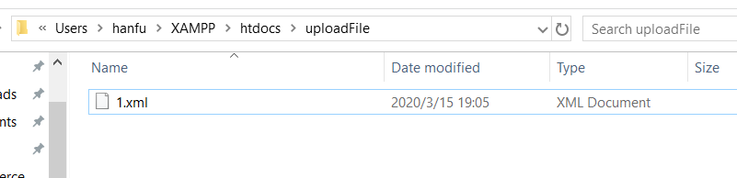

We can through the uploaded link and find uploaded file in address listed in last step.
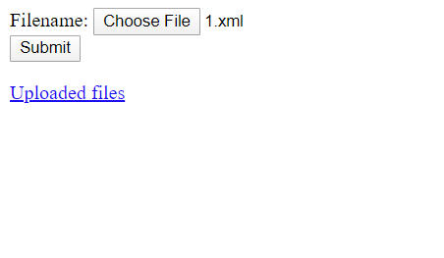

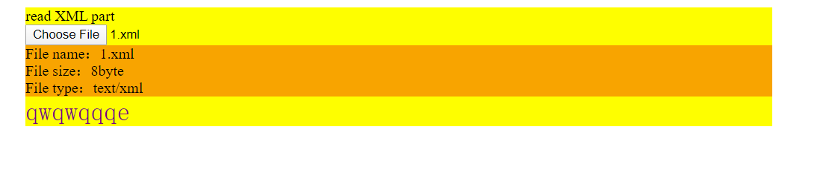
By using these file, we need XAMPP to connect database. Open apache and mysql
Delete index.html in XAMPP/htdocs.
Create a new folder named uploadFile.
Paste these two file in XAMPP/htdocs and modify content with annotation.
Open browser(Chrome) and enter 127.0.0.1

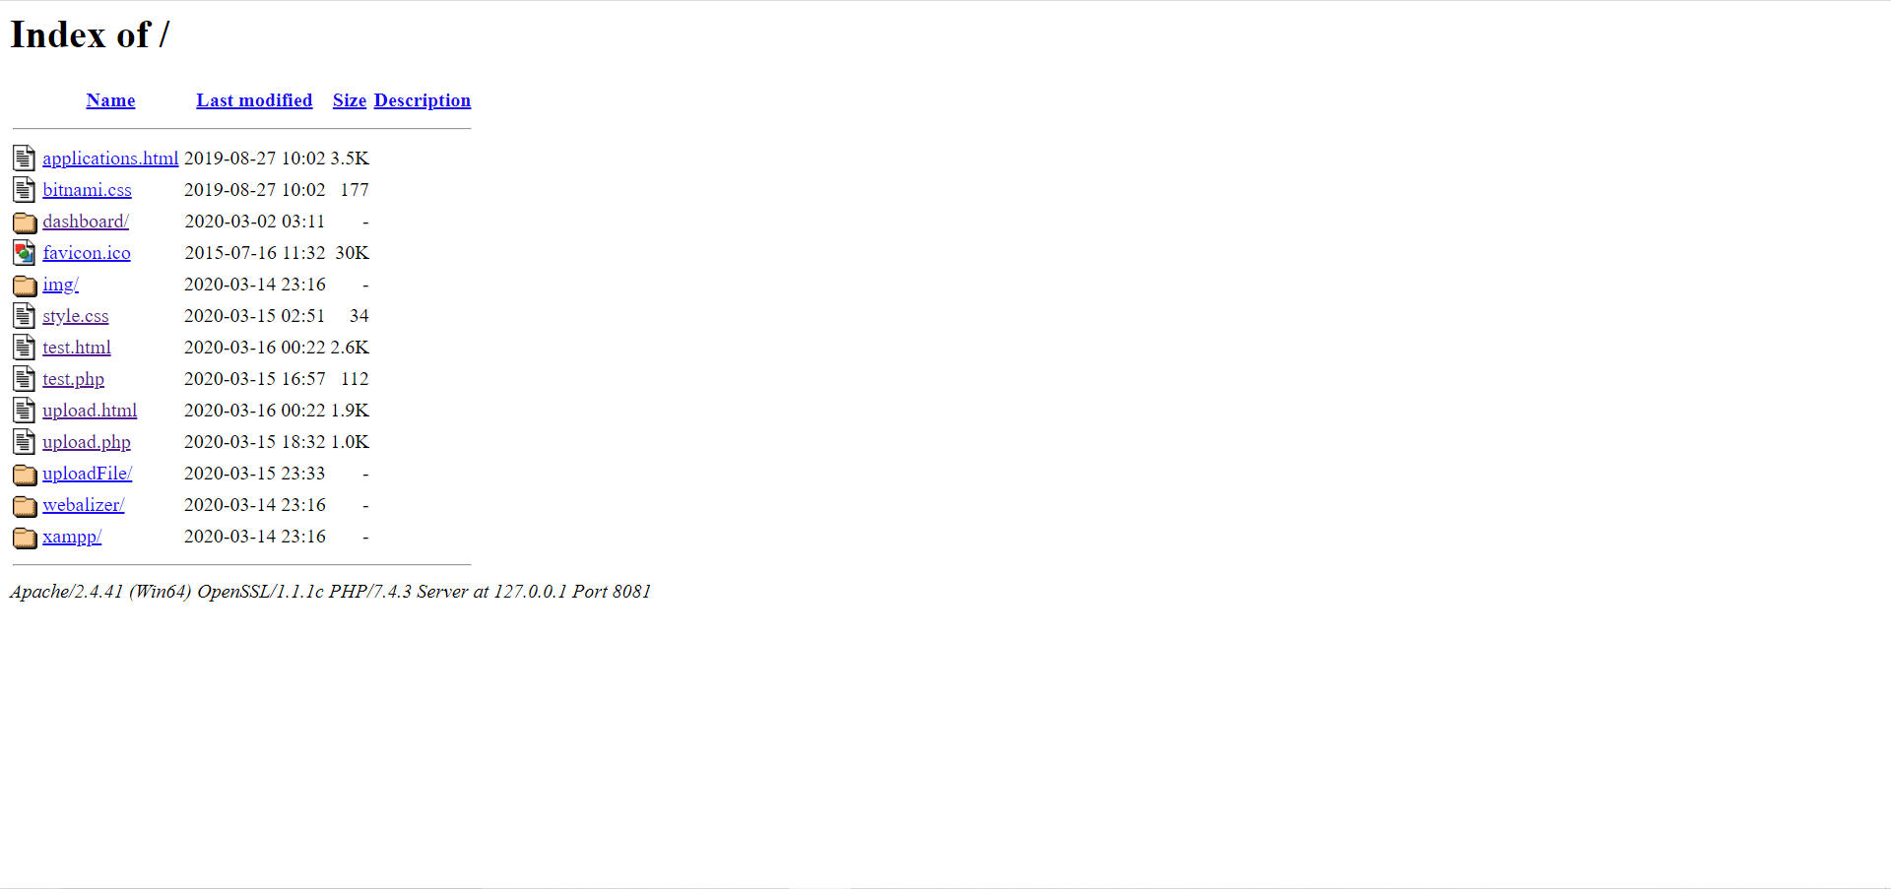
If you can see a page like this, then everything is ready, click upload.html and have a try.

Now, i am learning how to add these file to plugin, so if you have any suggestion or if you are familiar with related operation, please give me a favor, thanks.

